NASPA Executive Board Committee Meeting
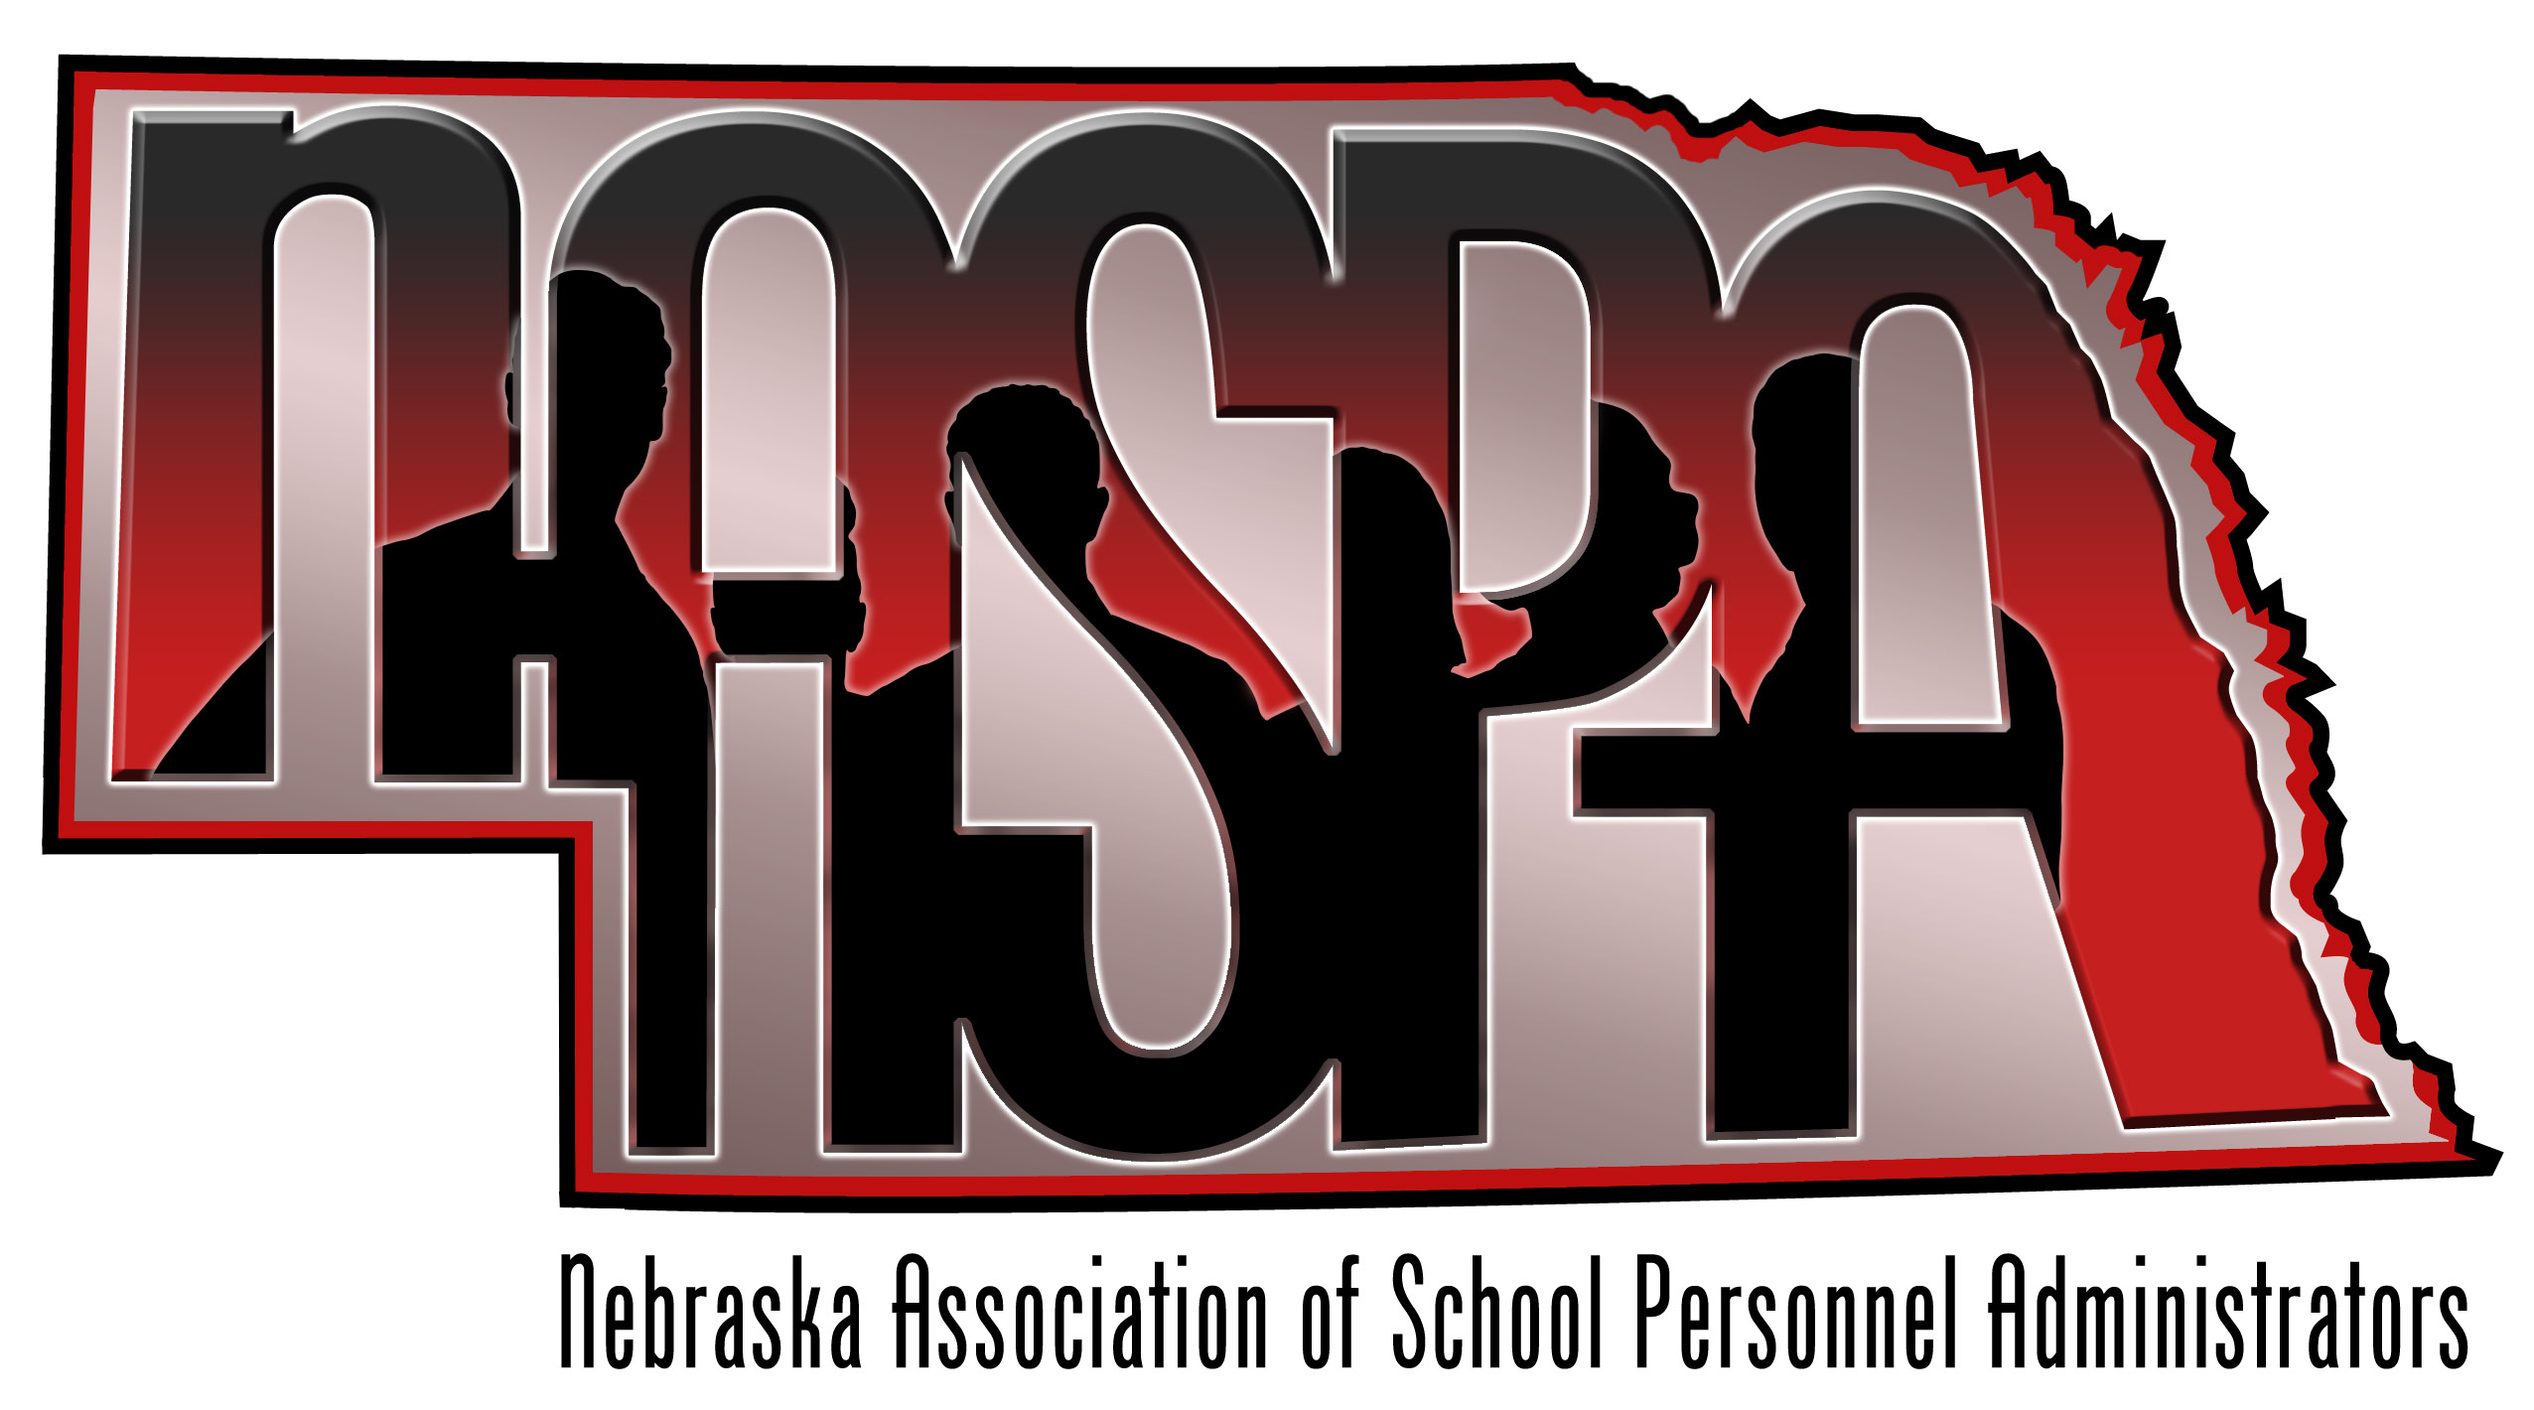
November 14, 2014

AGENDA

- Welcome and introductions

- Insurance Update
  - CHI/BCBS Update?
  - BC/BS rate increase
  - Dual Option: Anyone looking at this for PPACA hourly people (subs, coaches, intermittent staff)

- PPACA
  - Reporting and preparations
  - Newest lawsuit: State Exchanges

- Missouri Valley
  - Who is attending
  - NASPA presentations?

2014-2015
Continuing projects
● Create more presentations webinars
● Increase presentation venues
● Website create
and maintain
● New: Published webinars
● Completed on website:
○ Constitution & ByLaws
○ Save the Date for the annual conference
○ Minutes from the annual conference
○ List of current membership to include name/title/district
○ Conference Agendas from previous conferences
○ NASPA email
○ List of presentation topics
○ Link to AASPA website
○ Member login

- Budget Update – Amy

- NCSA/legislative Update – Mike, Dan, ?
  - New Legislators
  - Education Committee seat

- Other Topics

- Future Meetings/ Dates
Meeting Dates:
February 13 @ NCSA in Lincoln
April 10 @ NCSA in Lincoln

