NASPA

SPONSORSHIP OPTIONS

Please check the amount of your donation:

- FRIEND OF NASPA $100.00

- BRONZE DONOR $150.00

- SILVER DONOR $200.00

- GOLD DONOR $250.00

- PLATINUM DONOR $500.00

THANK YOU for your support!!!!
Nebraska Association of School Personnel Administrators

2012-2013

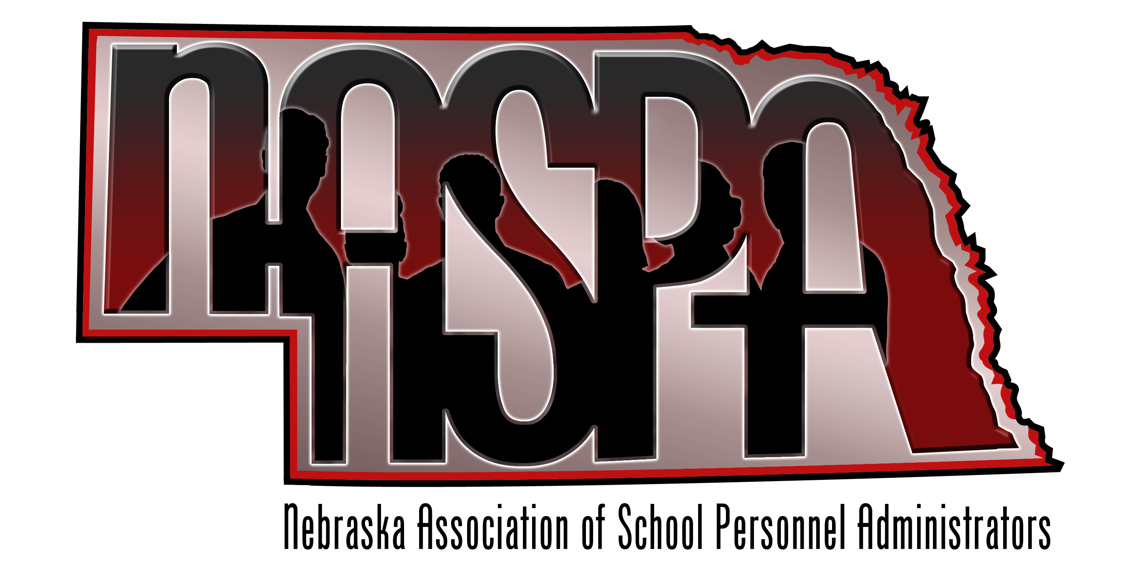
NASPA
455 South 11th Street, Ste A
Lincoln, NE 68508
Phone: (402) 476-8055
Fax: (402) 476-7740

Executive
President
Kevin Chick
Director of Personnel
Millard Public Schools
(402) 715-8040
kchick@mpsomaha.org

Vice President
Kay Byers, Ph.D
Supervisor of Elementary Personnel
Lincoln Public Schools
(402) 436-1577
kyers@lps.org

Secretary/Treasurer
Jenise Straight
Director of Special Services
ESU #9
(402) 463-5611
jstraigh@esu9.org

Board

In 2004, a group of Nebraska School Personnel Administrators met to form a professional group to promote the work and goals of bringing high quality professionals to work in Nebraska schools. With the help of the Nebraska Council of School Administrators we were able to form a professional group and organize under the title of Nebraska Association of School Personnel Administrators. In the ten years we have been in existence, we have grown to 50 members representing 27 school districts and ESUs across Nebraska.
Our organization’s mission is to foster the staffing of school systems with the highest qualified individuals; encourage and assist in the development and utilization of sound school personnel administration practices; and generally advance the cause of public education.
In order for our organization to continue and grow in our professional mission, it is necessary to ask for financial support from those entities that have a vested interest in education. Therefore, we are asking for your financial support through a sponsorship in one of the following categories:

Friend of NASPA ($100.00)

Bronze Donor ($150.00)

Silver Donor ($200.00)

Gold Donor ($250.00)

The NASPA organization will list, with your permission, your organization as a sponsor in our group and public communications. Your support for NASPA will help to further the work of bringing quality educators to work in Nebraska schools.

We appreciate your review of this material and your consideration of support. If you have any questions or comments, please contact:

Amy Poggenklass

Phone: (402) 476-8055

Or email

amy@ncsa.org

Your investment in

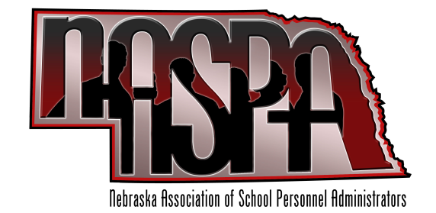
is greatly appreciated!
Listing Information

Your Name/Organization

Address

City/State/Zip Code

Contact Name

Phone Number

Email Address

Fax
Make checks payable to:
NASPA
Mail check to:
Amy Poggenklass
NASPA Liaison
455 South 11th Street, Ste A
Lincoln, NE 68508

