NASPA Executive Board Committee Meeting
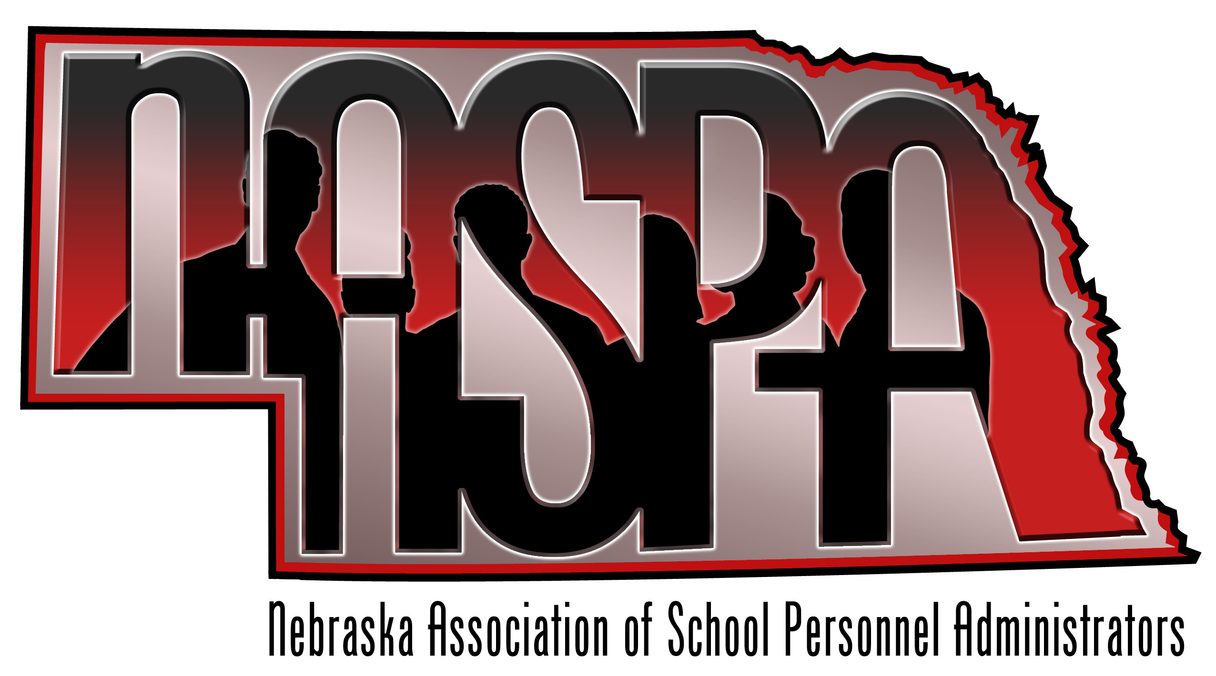
November 8, 2012

AGENDA

- Website
    - Currently is not operational, need to get up and running and functional
    - -Possible listserv, social media presence, goals for this year?

  - future plans for the website, which would include (Some items from last year):
    - -Executive Board contact info √
    - -Minutes from the annual conference
    - -Save the Date for this year’s conference
    - -List of current membership to include name/title/district
    - -Conference Agendas from previous conferences
    - -Link to AASPA website
    - -Constitution & By-Laws
    - -List of presentations members would be willing to present at various conferences
    - -NASPA email
    - -Link to Social Media (Twitter, Facebook, LinkedIn?)

- Nebraska Teacher & Principal Performance Frameworks
- Letter from NASPA
- Attendance at State Board Meetings

- Organizational Structure of NASPA
- Term of executive board
- Explore creating regions
- Recruitment of membership from smaller districts
- Possible second NASPA conference…..HR support Staff?

- Possible presentation topics for 12-13
- How many
- What conferences do we target?

- MVSPA – December 13-14-Kansas City
- Possible NASPA presentation?

- NASPA Conference – June 27-28, 2012 in Nebraska City
Reservations are made?
Save the date in March
Send reservation materials in May
Program ideas???
Door prizes – budget??

- Future Executive Board Meetings
February 7th
April 11th
Meet at the NCSA Building at noon – networking lunch followed by the board meeting.

