NASPA Executive Board Committee Meeting
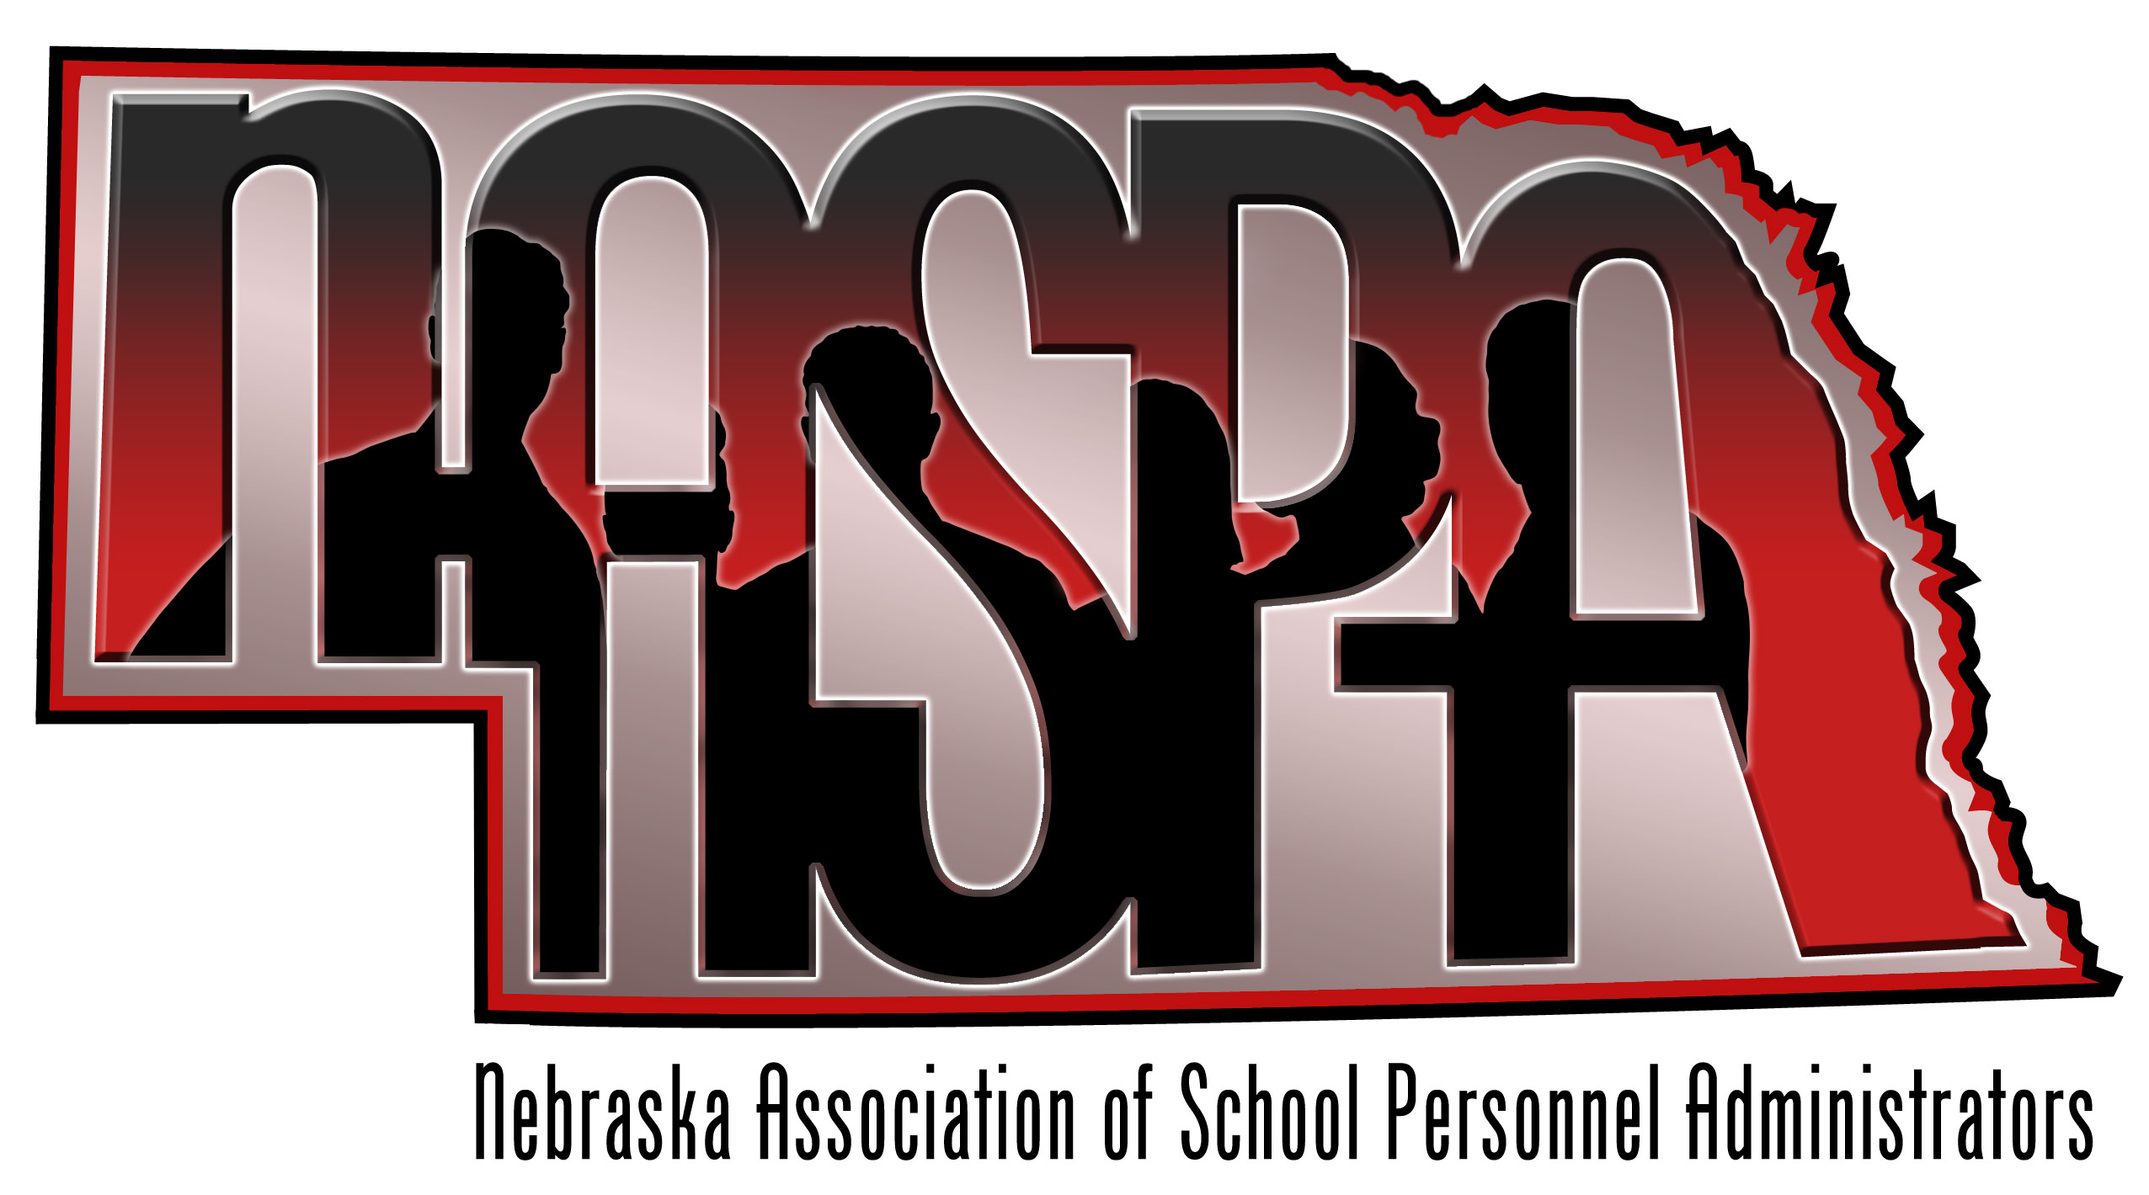
April 11, 2013

AGENDA

- Website-Update from Erin
Erin is still researching some low cost options for an easy to maintain NASPA website that we can link to the NCSA website. She will have another update at out June meeting

- Update from Dan Ernst – Content testing for teachers and principals for licensure
Dan stated that this will happen. We all need to be aware of this as it will impact people who are coming into Nebraska or those who will be adding a certification. Dan has reviewed the administrative content test and he believes most people should be in good shape. It is a national test (ETS is the vendor). Nebraska, Iowa, and Montana were the only states without a teacher test. It is an effort to ensure that colleges are providing quality experiences for their students. If you will be changing certifications, you will have to take a test beginning August of this year. Here is how they are rolling this out:

August 1st 2013, teachers will be encouraged to take the Praxis II test. They will use these results to determine what the cut-score will be for Nebraska. Goal will be full reciprocity between states…Dan is not sure if that will happen or not.

August 1st, 2014, teachers will have to take the test, but there will be no qualifying score.

August 1st, 2015, teachers will have to show evidence of completion and pass

- Review new vendor brochures and NASPA brochure
We reviewed two updated NASPA brochures. One for Membership and one for Vendors to support our Summer Retreat. The brochures are attached.

- Organizational Structure of NASPA – Will send out changes to by-laws
We will vote on some proposed changes to our by-laws which concern the length of term of the board at out Summer Retreat.

- NASPA Conference – June 27-28, 2012 in Nebraska City
Reservations are made
Save the date has been sent
Send reservation materials in May
Will discuss program so far
Door prizes – Update
Ideas for sponsorship

Plans are underway. Reservation information will be coming out in the next few weeks along with a draft agenda. We hope all can attend
- Budget Update – Amy
Not much action with the budget. This will change as we approach the summer retreat.

- NCSA/legislative Update – Mike (If Available)
553 retirement bill. Mike believes it is time for the state to pay more. All 3 groups (NCSA, NRCSA, and NSEA) are in line. May need votes to override a potential Governor’s veto

- Future Meetings
June 27 & 28 in Nebraska City

