NASPA

Questions

Please contact Amy Poggenklass at amy@ncsa.org or (402)476-8055.

Join NASPA Today!!
Nebraska Association of School Personnel Administrators

2013-2014

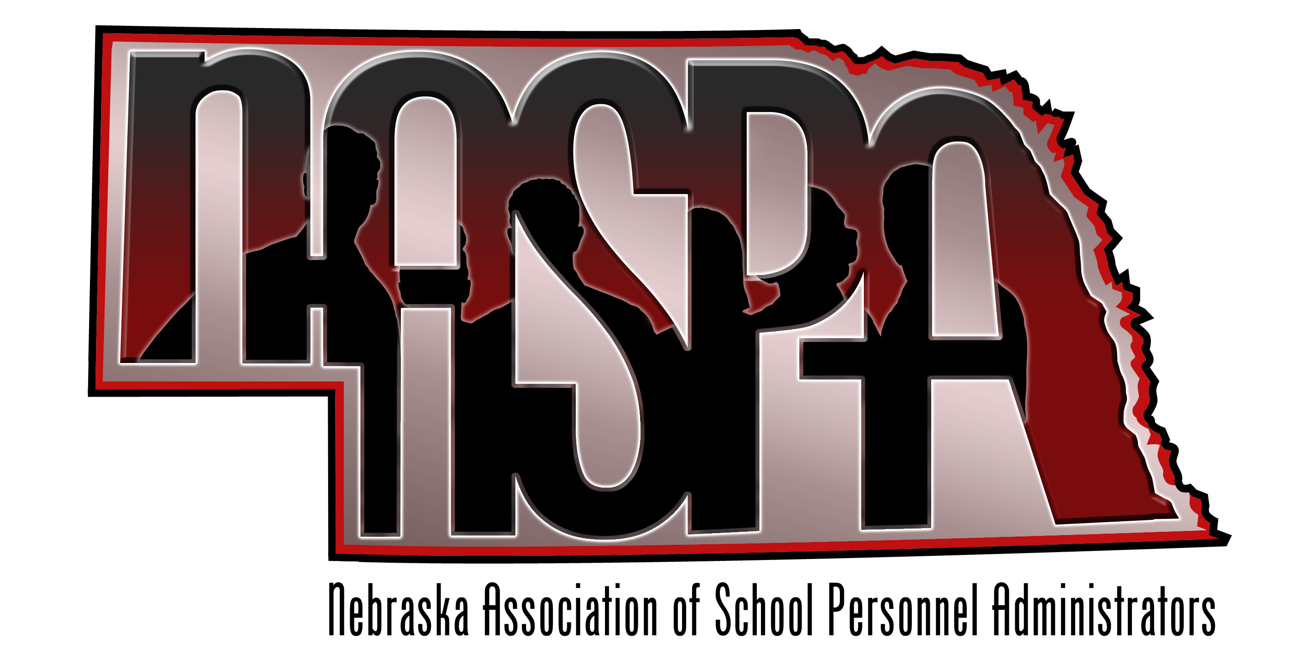
NASPA
455 South 11th Street, Ste A
Lincoln, NE 68508
Phone: (402) 476-8055
Fax: (402) 476-7740

Executive

Board

Who we are:
- Chartered in 2004
- 50 members
- Representing 27 school districts and ESUs
- Assist Districts
  - Large & Small
  - Metro & Rural
- Mentorship & support to Human Resource personnel
- Partner organization of NCSA

What we offer:
- Access to networking among human resource personnel
- Access to expert human resources information
- Presentations at Educators Forum, NASB, NRCSA, NASBO, Labor Relations and more
- Annual summer retreat
- Webinars

Potential Members include:
- Human Resource Directors
- Superintendents
- Assistant Superintendents
- District Professional Staff such as administrative assistants, office staff, business managers, bookkeepers, etc.
- Anyone in your district responsible for personnel

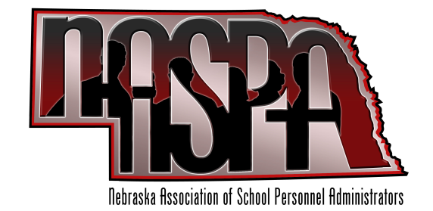
NASPA
455 South 11th Street, Ste A
Lincoln, NE 68508
(402)476-8055

President
Kevin Chick
Millard Public Schools
kchick@mpsomaha.org

Vice President
Kay Byers, Ph.D
Lincoln Public Schools
kyers@lps.org

Secretary/Treasurer
Jenise Straight
ESU #9
jstraigh@esu9.org

Past President
Sharra Smith, Ed.D
Bellevue Public Schools
sharra.smith@bpsne.net

Legislative Liaison
Nancy Biggs, Ph.D
Lincoln Public Schools
nbiggs@lps.org

Member-at-Large
Eric Weber, Ed.D
Westside Community Schools
eweber@westside66.org

Member-at-Large
Erin Heineman
Lexington Public Schools
erin.heineman@lexschools.org

